FEBRUARY 2024

**NEWLETTER**

**First Presbyterian Church of Croswell**

**Web Page:** https://**Croswellpresbyterian.org**





**Prayer Requests**

Prayers that we hold silent in our hearts.

Claire Gordon – cancer

McEy Neaves – praise that immunotherapy is working.

Lisa Haddix’s dad David –lung cancer.

Delta, friend of Pastor Bill and Dayna, going through rehabilitation

Carlene Black – recovering.

Cheryl Hosler’s nephew Jeff – surgery for removal of a tumor

Those involved in the fatal accident on Lakeview Hills hill during bad storm January 19th.

Prayers for those in nursing homes and adult foster care.

Prayers for those in our community suffering loss of loved ones.

|  |  |  |
| --- | --- | --- |
| **Deacons, Elders, Lent**  The annual Congregation Meeting of First Presbyterian Church will be held on Sunday, February, following the 10:00a.m. worship service. Some of what will be decided at the meeting will keep the church humming along smoothly for another year. But also, church members who have agreed to serve and lead the congregation will be put in a place that day, in a brief ceremony called *Ordination* and Installation*.* Let’s look at two *orders* or “categories” of servants and leaders who will be begin at their posts on February 4.  **Deacons** are described in the Bible as people of compassion, witness and service who reach out to the sick, the home-bound, the poor, the friendless, the lost, folks oppressed by societal injustice, anyone in need or distress. Spiritual qualities of deacons include a good character, a good reputation, people who aim to follow Jesus’ teaching of loving one another; they are capable of empathy and compassion.  **Ruling Elders** possess particular gifts useful in the governance of the church. They are people of wisdom who are mature in the Christian faith. Elders have demonstrated skills in leadership, and like the Deacons, are capable of expressing empathy and compassion. The title *Ruling Elder* does not mean they “lord it over others.” Rather, think of the *wooden ruler* that you occasionally use to carry out the D.I.Y. projects around your home. *Ruling Elders* measure how close or how distant the teaching and activities of the church are to the Bible, and in particular to what Jesus taught. So Ruling Elders are mature spiritual leaders who, along with the pastor, keep the church grounded in the teaching of the Bible and God.  I ask you to pray regularly for the Deacons and Ruling Elders, in fact all of our church leaders, and if possible, do be present when we will celebrate their ministry at the Congregational Meeting on February 4.  **Lent** is a season of forty days, not counting Sundays, which begins on Ash Wednesday and ends on the Saturday before Easter Sunday. During this time, we Christians remember the 40 days Jesus spent fasting in the desert and enduring temptation by Satan. Important days during Lent are Palm Sunday, Maundy (Holy) Thursday and Good Friday. Churches often share Holy Communion on Maundy Thursday, as a way of recalling Jesus’ Last Supper with his twelve disciples just prior to his being arrested and crucified. Christians gather for solemn worship on Good Friday, during the hours (1:00 to 3:00 p.m.) that Jesus was on the cross. The purpose of Lent is to prepare Christians for Easter, by prayer, worship, repentance, sacrificial giving, simple living, and giving up luxuries as a way of imitating Jesus’ 40 days of fasting. Let us meet together for worship at First Presbyterian Church during Lent. God will make it both meaningful and memorable.  Pastor Bill Wright | | |
|  |

|  |
| --- |
|  |

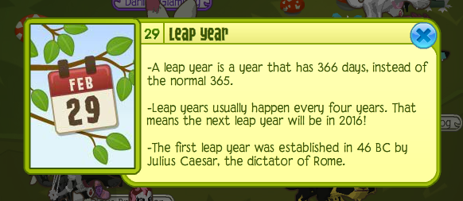

INSPIRATION STATION

“If you want to feel rich, just count the

things you have that money can’t buy.”

- Old Proverb

“If you are going through hell, keep

going.” - Winston Churchill

“Lord, please fill my mouth with worth-

while stuff, and nudge me when I’ve

said enough.” - Unknown

“Without faith a person can do nothing;

with it all things are possible.”

- Sir William Osler

“Age is a question of mind over matter.

If you don’t mind, it doesn’t matter.”

- Mark Twain

“Wisdom is supreme, Therefore get

wisdom. Though it cost all you have

get wisdom.” - James 4:7

“Receive the gospel of Christ,

whose messengers you now are.

Believe what you read,

teach what you believe,

and practice what you teach.”

- Rite of Ordination of a Deacon

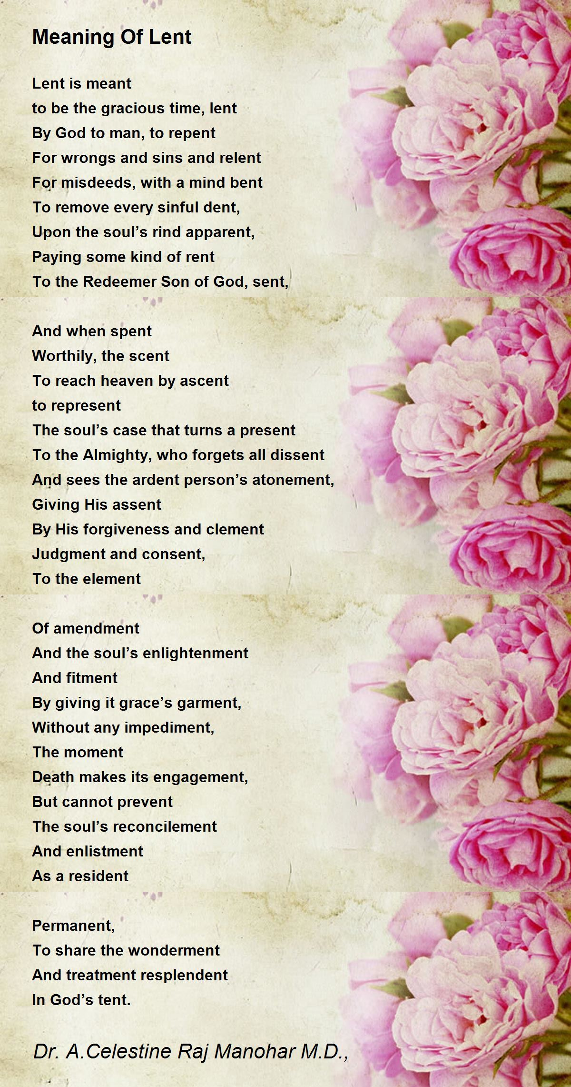

Community Lenten Schedule held Wednesdays at 6:00 p.m.

Feb. 21 at Bethel Community Church

Feb. 28 at First Presbyterian Church of Croswell

 Lenten Service at First Presby. Church 6PM

Mar. 6 at Cros-Lex Assembly of God

Mar. 13 at Croswell Wesleyan Church

Mar. 20 at Lexington United Methodist Church

All of the above services will have snacks served after the service.

Croswell Free Methodist Church WILL be hosting the Community Good Friday Service 12:00 noon

**FEBRUARY SCRIPTURE READINGS**

**February 18th, 2024**

**1st Sunday in Lent**

Gen. 9:8-17

Ps. 25:1-10

1 Peter 3:18-22

Mark 1:9-15

**February 25th, 2024**

**2nd Sunday in Lent**

Gen 17:1-7, 15-16

Ps. 22:23-31

Rom. 4:13-25

Mark 8:31-38 or Mark 9:2-9

**February 4th, 2024**

**5th Sunday after Epiphany**

Isa. 40:21-31

Ps. 147:1-11, 20c

1 Cor. 9:16-23

Mark 1:29-39

**February 11th, 2024**

**Transfiguration of the Lord**

2 Kings 2:1-12

Ps. 50:1-6

2 Cor. 4:3-6

Mark 9:2-9

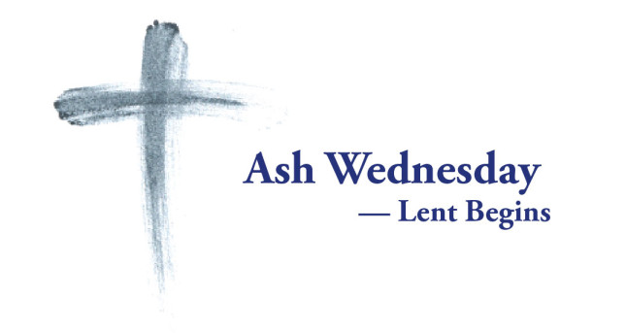





**February 1**

Candy-Making Day

Car Insurance Day

Ellis Island Day

Divorce Day

**February 2**

Bubble Gun Day

Crepe Day

Dump Your Significant jerk Day

Give Kids A smile Day

Groundhog Day

Wear Red Day

Working Naked Day

**February 3**

National Ice Cream for Breakfast Day

National Play Outside Day

Take Your Child to the Library Day

**February** **4**

I Heart Horror Day

Quacker Day

Facebook’s Birthday

**February 6**

Shower With A Friend Day

World Nutella Day

Lame Duck Day

Wear Orange Day

**February 7**

Wave All Your Fingers At Your Neighbor’s Day

Who Shall I Be Day

**February 8**

Laugh and Get Rich Day

National Giving Hearts Day

**February 9**

Cut the Cord Day

National Pizza

Read in the Bathtub Day

Toothache Day

**February 10**

Umbrella Day

**February 11**

Be Electrific Day

Don’t Cry Over Spilled Milk Day

Man Day

National Pork Rind Day

National Shutin Visitation Day

**February 12**

Lincoln’s Birthday

**February 13**

Desperation Day

International Pancake Day

Madly In Love With Me Day

National cheddar Day

Paczki Day

**February 14**

Ash Wednesday

International Kissing Day

Library Lovers Day

**February 15**

Love Reset Day

National Friendzone Day

National Gum Drop Day

National Hippo Day

**February 16**

National Almond Day

No One Eats Alone Day

Tartar Sauce Day

**February 17**

My Way Day

Who Shal I Be Day

**February 18**

Cow Milked While Flying In An Airplane Day

Global Drink Wine Day

National Hate Florida Day

**February** **19**

Chocolate Mint Day

National Lashes Day

Best Friends Day

**February 20**

National Comfy Day

International Pechakucha Day

National Hemisphere Hoodie Hoo Day

**February 21**

Hockey Stick Salute Day:

**February 22**

Discover Girl Day

The Great American Spit Out

National Margarita Day

World Thinking Day

**February 23**

National Dog Biscuit Day

Single Tasking Day

Skip The Straw Day

Tootsie Roll Day

**February 24**

Rubber Ducky Day

**February 26**

For Pete’s Sake Day

National Cupcake Day

National Set A Good Example Day

Play More Cards Day

**February 27**

National Kahlua Day

International Polar Bear Day

**February 28**

National Public Sleeping Day

National Tooth Fairy Day

Pink Shirt Day:

**February 29**

International Toast Day

National Chili Day

**Leap Year**

Bachelor’s Day

Superman’s Birthday

National Time Refund Day

WEEK EVENTS

Wk.1 Women’s Heart Wk

World Interfaith Harmony Wk

Wk. 2 Tinnitus Awareness Wk

Dump Your Significant Jerk Wk

Solo Diners Eat Out Wk

Love Makes the World Go Round; But, Laughter Keeps U From Getting Dizzy Wk

Wk 3 Great Backyard Bird Count Wk

Texas Cowboy Poetry Gathering

Love A Mench Wk

National Sauna Wk

G. Washington’s Birthday

National Secondhand Wardrobe

National Condom Wk

Through With The Chew

Wk 4 National Eating Disorders Awareness Wk

National Invasive Species Awareness Wk

Wk 5 International Energy Wk

International Petroleum Wk

MONTHLY EVENTS

National Snack Food Month

Pull the Sofa Off the Wall Month

Spunky Old Broads Month

Plant the Seeds of Greatness Month

National Prevent a Litter Month



SPECIAL DAYS IN FEBRUARY

**From your little Library in the corner….**

“It was a dull autumn day and Jill Pole was crying behind the gym. She was crying because they had been bullying her. This is not going to be a school story, so I shall say as little as possible about Jill’s school story, so I shall say as little as possible about Jill’s school, which is not a pleasant subject.” Want to hear more? Check out **The Silver Chair**, by C.S. Lewis. (Yellow Dot – Children)

“’I will tell you what a tragedy is. I will show you how to waste your life. Consider this story from the February, 1998 Reader’s Digest: A couple took early retirement from their jobs in the Northeast five years ago when he was 59 and she was 51. Now they live in Punta Gorda, Florida, where they cruise on their 30-foot trawler, play softball and collect shells.... Picture them before Christ at the great day of judgment: ‘Look, Lord. See my shells.’ That is a tragedy.” From **Don’t Waste Your Life**, by John Piper. (Christianity – Beige Dot)

“This is the best book about Jesus I have ever read....Yancey gently took away my blinders and blazed the trail through my own doubting fears....” Intrigued? Read **The Jesus I Never Knew**, by Philip Yancey. (Jesus – Primrose Dot)

5th Audrey Warner

11th Carter Young

15th Raeleen Sample

20th Tom Fockler

24th Steve Oldford

28th Kyle Hosler









| FEBRUARY 2024  Love letterCross country skiingSnowLove letterCross country skiingSnowLove letter  Dates to Remember | | | | | | |
| --- | --- | --- | --- | --- | --- | --- |
| S | M | T | W | T | F | S |
|  |  |  |  | 1 | 2 | 3 |
| 4  Worship with  Holy Communion  10 a.m. | 5 | 6 | 7 | 8 | 9 | 10 |
| 11  Transfiguration  Sunday  Worship  10 a.m. | 12 | 13  Sessions Mtg. 7 p.m.  Deacons Mtg. 6 p.m. | 14 | 15 | 16 | 17 |
| 18  1st Sunday in Lent  Worship  10 a.m.  4 | 19 | 20 | 21  Community. Lenten Service at Bethel Comm. Church 6 pm | 22 | 23 | 24 |
| 25  2nd Sunday in Lent  Worship  10 a.m. | 26 | 27 | 28  Lenten Service at First Presby. Church 6PM | 29 |  |  |

First Presbyterian Church of Croswell

7 South Howard

Croswell, MI 48422

810-679-3352

Email: firstpresbycros@att.net

Visit Our Web Page: https://croswellpresbyterian.org



KIDS CORNOR

WELCOME REV. BILL WRIGHT AS OUR NEW PASTOR.



A tasty lunch was prepared by the Presbyterian Women. Thank you so much for all the work you do to make this event and all our events special.

