NEWSLETTER
First Presbyterian Church of Croswell
Web Page: https://Croswellpresbyterian.org
To view our service online, type into your browser: https://www.facebook.com/share/v/Sp81Xi763weTSfkt

January 2026

Why We Celebrate New Year’s Day
New Year’s Day is one of the most celebrated holidays worldwide, marking the beginning of a new calendar year. Across cultures and religions, it is a time for reflection, gratitude, and setting new goals. From ancient traditions to modern innovations, the significance of New Year’s Day lies in its universal message of hope and renewal.
Historical Origins
The celebration of the new year dates back over 4,000 years to ancient Babylon. Babylonians marked their “new year” during the spring equinox with an 11-day festival called Akitu. This celebration symbolized renewal and the planting season.
In 46 BCE, Julius Caesar established January 1st as the start of the year in the Roman calendar, honoring Janus, the god of beginnings and transitions. Janus, with two faces looking forward and backward, epitomized the essence of New Year’s Day: reflection on the past and anticipation of the future.
The Gregorian Calendar
The modern celebration of New Year’s Day stems from the Gregorian calendar, introduced by Pope Gregory XIII in 1582. This calendar refined the Julian system and solidified January 1st as the year’s start. This shift ensured alignment with the solar year and provided a uniform system for global observance of the new year.
Symbolism of New Year’s Day
New Year’s Day carries profound symbolism. It represents renewal, hope, and the opportunity to start afresh. As the clock strikes midnight, it signals a shared moment of transition, allowing people to let go of the past and embrace the possibilities of the year ahead.
The idea of new beginnings resonates universally, as people seek to improve themselves and the world around them. This symbolic fresh start provides emotional and psychological motivation.
Religious Significance
For many faiths, New Year’s Day is more than a secular event; it holds spiritual importance. In Christianity, January 1st is celebrated as the Feast of the Solemnity of Mary, Mother of God.
Hindu traditions, such as Ugadi and Gudi Padwa, observe their new year at different times based on lunar calendars, focusing on renewal and cleansing. Judaism celebrates Rosh Hashanah, the Jewish New Year, in autumn, emphasizing reflection and repentance.

Prayer Requests
Tom Fockler - surgery this week
Linemen/Utility Personal working in cold, windy conditions to restore power to those with outages.
Those in our church family going through tests, surgeries and recovering from recent surgeries.
Those experiencing colds/flus.
Those going through difficult times and suffering recent losses.
First responders (EMTs, Police and Fire fighters) and military active duty and veterans.
.


JANUARY QUOTES
Quotes to Inspire a Beautiful Fresh Start

The New Year always arrives with a sense of magic. It feels like the world gives us permission to pause, release what we’ve outgrown, and step into something softer, brighter, and full of promise.

The beginning of a new year reminds us that life is full of second chances. It encourages us to dream again, start again, and grow again at our own pace. It’s the perfect moment to embrace hope, reflect on how far we’ve come, and walk confidently into what’s next. A new year means new possibilities waiting for you.
May this year be the one where everything falls into place.

Here’s to 365 new chances to bloom.
New beginnings bring new blessings.
Step into the new year with courage in your heart.
This year, choose joy every day.
A fresh year is a gentle reminder to start again.
Let this year be your season of growth.
May your new year be filled with soft moments and sparkling joy.
Trust the magic of new beginnings.
This year is yours—shape it beautifully.
Walk into the new year with intention and gratitude.
May the next 12 months be your most beautiful chapter.
Let hope guide you into the new year.
This year, choose peace over pressure.

Short New Year Quotes

New year, new light.
Fresh year, fresh energy.
Hello, new beginnings.
A new year, a new you.
Choose joy this year.
This year feels golden.
Let the new year bloom.
Here’s to fresh starts.
This year is full of hope.
Turn the page.
New year, soft hearts.
Walk into the year with grace.
New chapter loading.
Cheers to new possibilities.

Let this year be the one where you believe in yourself fully.

Your goals are waiting—step toward them with confidence.
Growth happens when you decide you’re ready.
This year, invest in your dreams like they matter.
You are capable of rewriting your story.
Start where you are and rise.
Small steps lead to big transformations.
Don’t fear the new year—shape it boldly.
This year, say yes to opportunities that scare you a little.
Discipline today creates magic tomorrow.
Your future self will thank you for starting now.
Show up for yourself this year.
A new year is a reminder of your strength.
Be brave enough to try again.
Let this year be your breakthrough.

Happy New Year Quotes

Wishing you a year filled with warmth, joy, and sweet surprises.
May this new year bring you endless reasons to smile.
Happy New Year—may your heart stay light and your dreams stay big.
Sending you love and positivity for the year ahead.
May this year be gentle and full of blessings.
Cheers to a beautiful new year, filled with everything you’ve hoped for.

Inspirational New Year Quotes

The new year invites you to trust your journey.
You are allowed to start over—today and every day.
Let your heart lead the way this year.
Every new year brings a new lesson and a new blessing.
Let your dreams guide you into the next chapter.
You have the power to create a life you love.
Let the new year be a reminder of your resilience.
Your story is still unfolding beautifully.
Let faith carry you into the new year.
Be gentle with yourself—new beginnings take time.

Final Thoughts

The New Year is a reminder that you can begin again anytime—but there’s something magical about starting fresh on the very first day. Whether you’re stepping into the year boldly or gently, these New Year quotes can bring comfort, clarity, and motivation to your journey.

Unique New Year’s traditions to kick off 2026
How are you planning to celebrate New Year’s this year? While making New Year’s resolutions and hosting New Year’s Eve parties are timeless classics, there’s a whole world of New Year’s traditions that can make your celebrations even more memorable.
Jump off furniture
You may have seen this tradition in a New Year’s meme or two, but in Portugal, people quite literally leap into the new year. As the clock strikes midnight, it’s tradition to jump off a chair (or any furniture nearby) to symbolize leaving behind the old year.
Light oil lamps
It’s a New Year’s tradition in India to light oil lamps to symbolize inviting hope and positivity into the coming year—similar to how they celebrate Diwali. The warm glow represents new beginnings and the triumph of brightness over darkness.
Wear dotted clothing
Bring in good fortune by following this festive tradition from the Philippines. Locals believe that wearing clothing with polka dots will boost your luck for the year ahead. So, break out your most stylish dotted outfit and get ready to attract some extra good vibes.
Throw water out the window
In Puerto Rico, it’s believed that tossing a bucket of water out the window will drive away evil spirits lingering from the old year. To invite good luck in, sprinkle a little sugar outside your home. It’s a cleansing and sweet start to the year.
Ring a bell 108 times
This might be one of the best New Year’s traditions based on your zodiac sign: For those ringing in the start of a new 365 days in Japan, listen for the bells at midnight. Here, tradition dictates that Buddhist temples ring bells 108 times, based on the belief that it brings cleanness. And no, the tradition isn’t referring to the junk drawer you should have cleaned out a decade ago; it focuses on a cleansed heart, mind, soul and body. The concept is called joya no kane, and the reasoning behind the specific number is attributed to the 108 types of earthly desires humans are thought to have. The ringing of bells is said to help you leave your old, sad or frustrated self behind and enter the new year with a clear mind and happier resolutions.
Sip soup for the soul
There’s nothing like a hot bowl of soup to warm the soul in the winter, but South Korea’s tteokguk, a dish made of broth, rice cakes, meat and vegetables, is imperative to the country’s New Year’s traditions. South Korean New Year, known as Seollal, usually falls in late January or early February, and the soup is believed to bring those who eat it good luck in the new year.
Eat a sugar pig
Germans believe that pigs equal wealth, so for New Year’s, it’s commonplace to eat glücksschwein, pig-shaped marzipan candies that are both adorable and sweet. They’re thought to bring financial luck for the year ahead.
Toss a coin
It might seem counterintuitive to literally throw your money away, but in Romania, that’s exactly what they do for good luck at the start of a new year. Don’t worry, they aren’t emptying their bank accounts. But it’s believed that tossing a coin in a river will bring luck throughout the year.
Dec. 14
Monkey Day
Yoga Day
Dec. 15
Cat Herders Day
National Cupcake Day
National Wear Your Pearls Day
Dec. 16
National Chocolate-covered Anything Day
Barbie and Barney Backlash Day
Dec. 17
A Christmas Carol Day
National Re-gifting Day
National Say It Now Day
Clean Air Day
Dec. 18
Answer The Telephone Like Buddy the Elf Day
National Ugly Christmas Sweater Day
Underdog Day
Dec. 19
Look For An evergreen Day
National Emo Day
Dec. 20
Games Day
Mudd Day
Dec. 21
Go Caroling day
Humbug Day
Make Music Day in Winter
National Flashlight Day
Short Girl Appreciation Day
Shorts Day
Winter Solstice
Yule
Dec. 22
Be a Lover of Silence Day
Forefathers Day
Dec.. 23
Family Roots Day
Festivus
Dec. 24
Bald Eagle Day
Christmas Eve
Dec.. 25
Christmas
Christmas Pudding Day
Dec. 26
Boxing Day
National Candy Cane Day
National Whiner’s Day
National Thank-you Note Day
From your little Library in the corner….

“A tragic accident, a grief-stricken young widow, a lonely father and child – a tender story of two hearts broken by despair finding wholeness through patience, loyalty, and faith in God.” From Love Comes Softly, by Janette Oke. (adult fiction - purple dot)

How well do you know the Bible?? Who wore the coat of many colors? What were the gifts of the three wise men? Who did David defeat with a slingshot? Test your knowledge with this fun, challenging and educational book!! The Everything Kids’ Bible Trivia Book, by Kathi and Aubrey Wagner. (children - yellow dot)

Looking for something to do on a wintry day? How about listening to the New Testament read to you by a star-studded cast, including Samual L. Jackson, Denzel Washington, and 200 more! The Bible Experience: New Testament (19 audio CDs).

Did you know our Library has both Christian-based fiction and non-fiction available?? And there are tons of Christian-based games for family fun! There’s something for everyone – of ALL ages!

9th Jim & Sue Weller
15th Yvette & Ron Messner

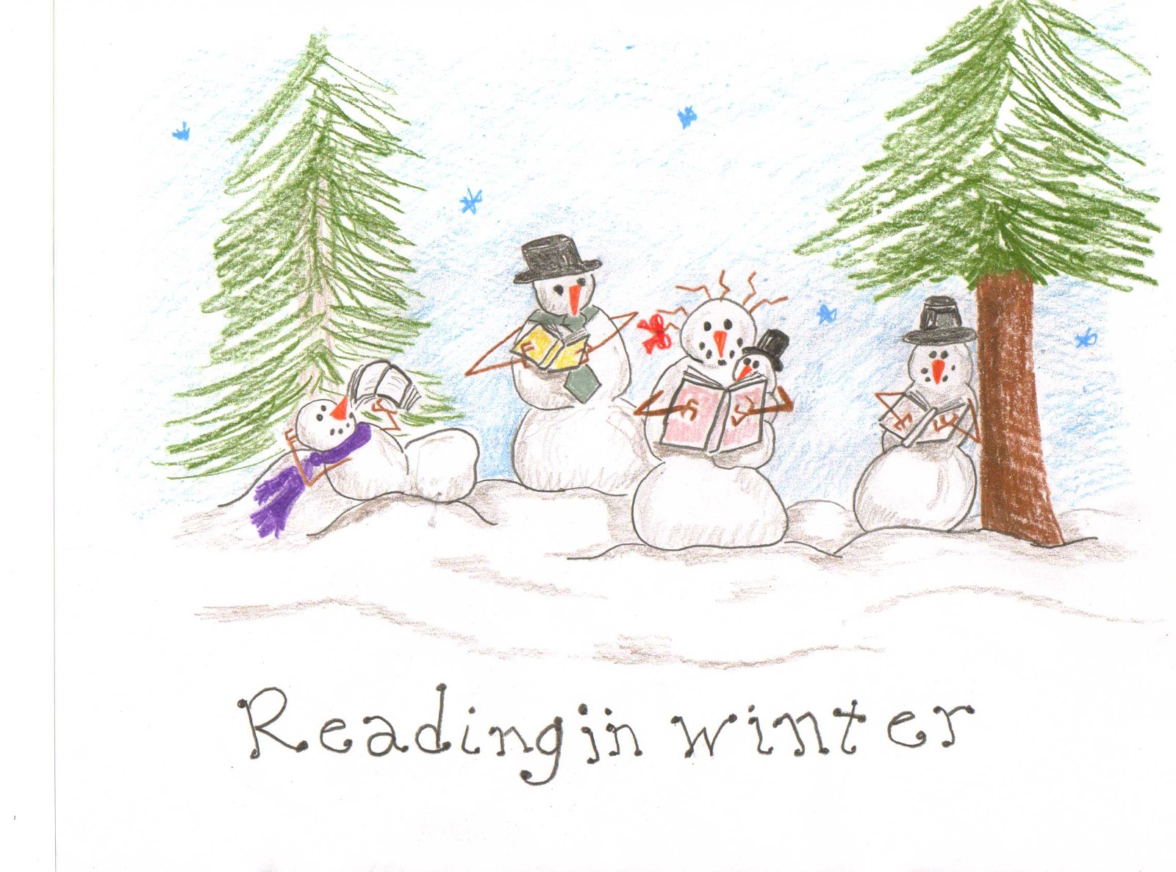

2nd Jane Kettlewell
Alexander Strand
6th Cindy Gardner
9th Grace Dungan
16th Kelly Kettlewell
20th Will O’Connor
\22nd Mcey Neaves
30th Kylee Barrett

SPECIAL DAYS IN JANUARY
Jan 14
Dress Up Your Pet Day
Organize Your Home Day
World Logic Day
Jan. 15
National Bagel Day
National Hat Day
Get to Know Your Customers Day
Jan. 16
Appreciate A Dragon Day
Fig Newton Day
Hat Day
National Nothing Day
Jan 17
Hot Heads Chili Day
Judgement Day
Popeye Day
National Use Your Gift Card Day
Jan 18
World Snow Day
Pooh (Winnie The) Day
Jan. 19
Blue Monday
National Popcorn Day
National Crowd Feed Day
Robert E. Lee Day
Tin Can Day
World Quark Day
Jan 20
Penguin Awareness Day
Tech Day
Jan. 21
International Squirrel Appreciation Day
International Sweatpants Day
National Hugging Day
National Hug Your Puppy Day
Jan 22
Answer Your Cat’s Questions Day
National Polka Dot Day
Jan. 23
Snowplow Mailbox Hockey Day
National Pie Day
National Handwriting Day
Jan 24
Belly Laugh Day
National Compliment Day
National Peanut Butter Day

Jan. 25
National Bible Sunday
Opposite Day
Jan. 26
Bubble Wrap Appreciation Day
Clashing Clothes Day
National Green Juice Day
National Peanut Brittle Day
Jan. 27
National Plan For A Vacation Day
Jan. 28
Library Shelfie Day
National Kazoo Day
National Gift of The Lady Bug Day
Rubber Ducky Day
Jan. 29
Freethinkers Day
National Puzzle Day
Jan. 30
Croissant Day
Fun at Work Day
Jan. 31
Fruitcake Toss Day
National Seed Swap Day
Appreciate Your Social Security Day

WEEK EVENTS
Wk.1 Someday We’ll Laugh About
This Wk
Elvis’ Birthday Celebration
Wk
Wk 2 Cuckoo Dancing Wk
National Mocktail Wk
Wk 3 Hunt For Happiness Wk
No Name Calling Wk
National Fresh Squeezed Juice
Wk
Wk.4 Meat Wk
Clean Out Your Inbox Wk

MONTHLY EVENTS
Book Blitz
National Be On-Purpose Month
National Cheesy Sock Month
National Polka Music Month
National Soup Month
Oatmeal Month
Train Your Dog Month
Walk Your Pet Month
Jan. 1
New Years Day
First Foot Day
New Year’s Dishonor List Day
Jan. 2
55-MPH Speed Limit Day
National Buffet Day
Happy Mew Year for Cats Day
Jan. 3
Drinking Straw Day
Festival of Sleep Day
National Chocolate Covered Cherry
National Play Outside Day
Jan. 4
Tom Thumb Day
World Hypnotism Day
Jan. 5
National Bird Day
Monopoly Game Day
Twelfth Night
Whipped Cream Day
Jan. 6
National Bean Day
National Shortbread Day
Three Kings Day
Jan. 7
I’m Not Going To Take It Anymore Day
Old Rock Day
National Bobblehead Day
Jan. 8
Bubble Bath Day
National English Toffee Day
Snuggle A Chicken Day
National Joy Germ Day
Jan. 9
Balloon Ascension Day
Chick-Fil-A Peach Bowl
Jan. 10
Eagle Day
Houseplant Appreciation Day
Jan. 11
Girl Hug Boy Day
National Milk Day
National Sunday Supper Day
World Sketchnote Day
Jan. 12
Kiss A Ginger Day
National Hot Tea Day
Jan. 13
Make Your Dream Come True Day

Dates to Remember


 |  | JANUARY 2026
S | M | T | W | T |  | F |  | S
 |  |  |  | 1  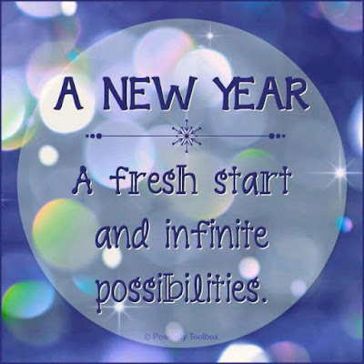 | 2 | 5 | 3.
4.  10am Worship  Pulpit Supply  Worship & Music Comm.. | 5 | 6.  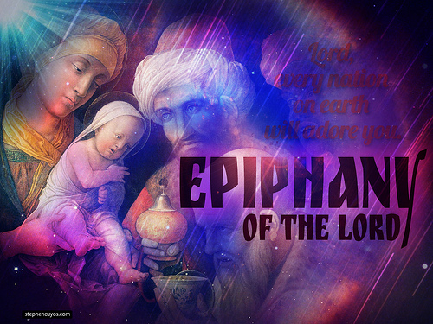 | 7. | 8. | 9. |  | 10.
11.  10 am Worship  Communion  Pulpit Supply  Rev. Kim Strunz | 12 | 13.  Deacon’s Mtg. 6:00 pm  Session Mtg. 7:00 pm | 14. | 15.  Food Give-away,  12-2 pm  Valiant Ministries | 16. |  | 17.
18.  10 am Worship  Pulpit Supply  Rev. Linda Fuller | 19. | 20. | 21. | 22. | 23. |  | 24
25.  10 am Worship  Pulpit Supply  To be determined | 26 | 27. | 281. | 29 | 30 |  | 31

First Presbyterian Church of Croswell
7 South Howard
Croswell, MI 48422
810-679-3352
Email: firstpresbycros@gmail.com
Visit Our Web Page: https://croswellpresbyterian.org
To view our services online copy and paste into your browser: https://www.facebook.com/share/v/Sp81Xi763weTSfkt

KIDS CORNOR

