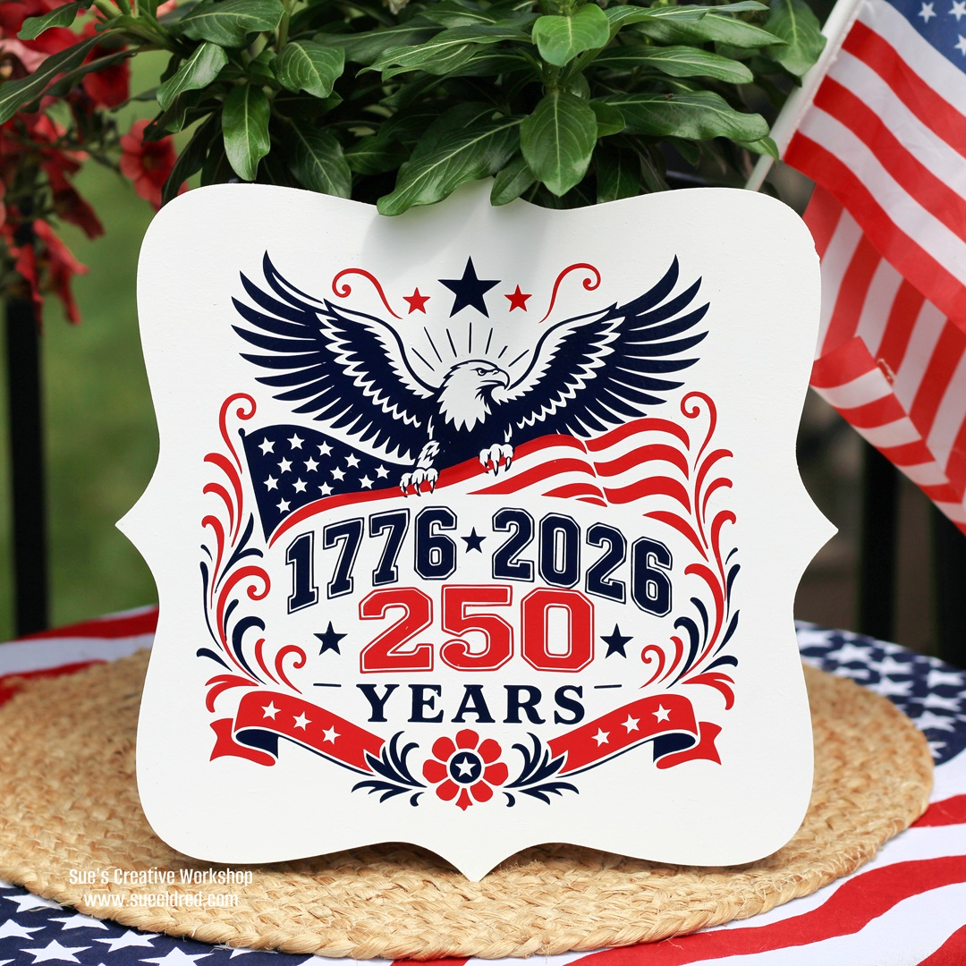
NEWSLETTER
First Presbyterian Church of Croswell
Web Page: https://Croswellpresbyterian.org
To view our service online, type into your browser: https://www.facebook.com/share/v/Sp81Xi763weTSfkt
JULY 2026

Reflections
We do not like to be new–made; we are afraid of it; it is throwing us out of all our natural ways, of all that is familiar to us. We feel as if we should not be ourselves any longer, if we do not keep some portion of what we have been hitherto; and much as we prefer in general terms to wish to be changed, when it comes to the point, when particular instances of change are presented to us, we shrink from them, and are content to remain unchanged.
In a higher world it is otherwise, but here below to live is to change, and to be perfect is to have changed often.
Stations of the Cross
The Stations of the Cross are a ritual pilgrimage. Encouraged by the Franciscan community in charge of the Sepulchre of Our Lord at Jerusalem, this devotion was transferred to churches in Europe for the convenience of those who could not make an actual pilgrimage. Each “station” was an extension of a scene visited by pilgrims — an episode, according to tradition, made holy by being part of the overall self–giving of Our Lord’s suffering on the way to Calvary. This devotion became so popular that eventually it was approved for the whole church.
How to Find Meaning in Suffering
No one has ever fully understood why so many good people are forced to endure a great deal of emotional, physical, and/or spiritual pain. Simply realizing that suffering is a normal part of life can be the first step toward finding good in suffering. Suffering will always be a mystery. The Lord never said the Christian life would be easy. But he did promise that you will never be alone in the painful times of your life.

Solution
How, then, do we weather turbulence in the church today? I would suggest Ten Commandments:
- Thou shalt revere the teachings of the church. Respect its 20 centuries of wisdom, scriptural revelation, and tradition.
- Thou shalt pray.
- Thou shalt be aware of the presence of God throughout the day. Our faith is not primarily a set of regulations, but a relationship with a Person, Jesus Christ of Nazareth, the same yesterday, today, and forever.
- Thou shalt concentrate on the essential truths of the church found in the Nicene and Apostles’ Creed.
- Thou shalt read the Bible regularly.
- Thou shalt develop a habit of serious study.
- Thou shalt receive the Sacraments faithfully.
- Thou shalt live the original Ten Commandments. The tablets give to Moses on Mount Sinai were not the ten suggestions.
- Thou shalt concentrate on the heart of our religion: “Love God, Love one another.”
- Thou shalt remember the Paschal Mystery.

Prayer Requests

Jim Kettlewell now resides @ Lakeshore AFC
Prayers for Jane McLane and family on the passing of Ann McLane
Jim and Sue Weller and daughter Debbie - loss of husband/grandson-in-law Aaron
Continued prayers for Jon and Sharron Lusher
Lisa Haddix's sister Beth - surgery for breast cancer (healing and recovery)
Prayers for all to remain hydrated and safe during this extreme heat wave
Those in the military - prayers for safety and return home
Those going through difficult times, unemployment and recent losses of loved ones.
Prayers for our country and our leaders in all forms of government.
Praise for the USA's 250th celebration of freedom and independence

JULY QUOTES
"When you realize there is nothing lacking, the whole world belongs to you."— Lao Tzu
"The simple act of noticing can take you out of despair and into reality."— Gretchen Rubin
"Gratitude is a practice. Begin where you are."
— Unknown

July is full of tangible things to appreciate—long light, warmth, time with loved ones, the smell of summer. This is an excellent month to practice gratitude not as something you "should" do, but as something that naturally flows from paying attention. Notice what delights you. That noticing itself is the practice.

Growth Through Consistency
"We are what we repeatedly do. Excellence, then, is not an act, but a habit."— Aristotle
"The secret of getting ahead is getting started."
— Mark Twain
"A journey of a thousand miles begins with a single step."— Lao Tzu
"You don't have to see the whole staircase, just take the first step."— Martin Luther King Jr.
"The only bad workout is the one that didn't happen."
— Unknown
"Excellence is not a destination; it is a continuous journey that never ends."— Brian Tracy
"Start where you are. Use what you have. Do what you can."— Arthur Ashe
"Compound results come from consistent effort."
— Unknown

The middle of the year is when you see which commitments have stuck and which have faded. This isn't a moment to judge yourself—it's a moment to recommit with honesty. Consistency isn't about perfection. It's about showing up repeatedly, even when it feels small or invisible. The results reveal themselves over time.

July's warmth is literal, but it can also be emotional. This is a month when lightness becomes possible—when you stop fighting the season and let it simplify things. Joy isn't something you chase; it's what's left when you release the weight of unnecessary expectations.

Summer Renewal and Fresh Starts
"The greatest glory in living lies not in never falling, but in rising every time we fall."— Nelson Mandela
"Every morning brings new potential, but only if we choose to see it."— Ralph Marston
"July is the month of becoming. Whatever you've carried this far, you can set down and begin again."— Unknown
"The only way to do great work is to love what you do."
— Steve Jobs
"Renewal requires patience with ourselves."
— Sharon Salzberg
"You are not a drop in the ocean. You are the entire ocean in a drop."— Rumi
"Progress is made by effort, not by luck."— Ralph Marston

July sits perfectly between spring's initial push and autumn's harvest. This is the month when you can genuinely feel your growth from six months of intention. Renewal isn't about starting from scratch—it's about building thoughtfully on what you've already learned. The energy of midsummer supports this kind of steady, visible progress.

Summer heat often pushes us to slow down naturally. July is when we stop fighting that rhythm and lean into it instead. Stillness doesn't mean standing still—it means being present wherever you are. These quotes remind us that clarity and solutions often arrive in the quiet spaces, not in the noise.

Gratitude and Presence
"Gratitude turns what we have into enough."
— Melody Beattie
"The present moment is filled with joy and peace. If you are not experiencing it, it is because you are living in the past or future."— Thich Nhat Hanh
"Appreciating what shows up in your life changes your whole life."— Oprah Winfrey
"Let us be grateful to the people who make us happy."
— Marcel Proust
"Today is the day to be grateful for all that life brings."
— Unknown

The United States will celebrate 250 years of independence on July 4, 2026, marking the Semiquincentennial of the Declaration of Independence.
The 250th anniversary, also called the Semiquincentennial, commemorates the adoption of the Declaration of Independence in 1776, when the thirteen American colonies declared their freedom from British rule. This historic milestone reflects the founding ideals of liberty, equality, and self-governance, and honors the efforts of the Founding Fathers and early Americans who fought for independence and established the United States as a republic
Political and Social Context
In 1776, the American colonies were under British rule but increasingly resistant to taxation and restrictive policies. Key events leading up to the revolution included the Royal Proclamation of 1763, which limited westward expansion, and the Stamp Act of 1765, which imposed taxes on printed materials, sparking widespread protest and the famous slogan “no taxation without representation”.
Revolutionary War and Military Events
Tensions escalated into armed conflict with battles such as Bunker Hill in 1775, where colonial militias demonstrated their resilience despite heavy losses. By December 1776, the Continental Army, led by George Washington, faced severe challenges, including expiring enlistments and scarce supplies. Washington’s daring crossing of the Delaware River and subsequent victories at Trenton and Princeton revitalized the revolutionary cause and preserved the army

Declaration of Independence
The colonies formally declared independence from Britain on July 4, 1776, following the Second Continental Congress’s approval of the Lee Resolution on July 2. The Declaration of Independence, primarily authored by Thomas Jefferson, articulated the colonies’ right to self-governance and the principles of liberty and equality. This document became the foundation for the new nation and inspired future movements for freedom and civil rights
Cultural and Historical Significance
Life in 1776 was marked by uncertainty, sacrifice, and the struggle for self-determination. The revolutionary period saw the rise of intelligence networks, local militias, and the emergence of leaders who would shape the United States’ early government The events of this era set precedents for constitutional governance, popular sovereignty, and the protection of individual rights, which remain central to American identity
In summary, America 250 years ago was a nation in formation, defined by colonial resistance, revolutionary warfare, and the bold assertion of independence that laid the groundwork for the United States.


From your little Library in the corner….
“I hear the hoofbeats of the Four Horsemen approaching!” Who knows better than Billy Graham what is going on in today’s world. Approaching Hoofbeats compares the Book of Revelation with the current state of world affairs. It is hard to put down! (Note: The book was written in 1983.) From Approaching Hoofbeats: The Four Horsemen of the Apocalypse, by Billy Graham. (Gray dot – Famous Authors)

“Susanna and Manaen desperately search for hope and meaning – in a world where their love is forbidden. Others pray and wait for light, and all long for a vision of hope. Now a healer named Yeshua walks the streets of Jerusalem. Is He the true Messiah? or only another imposter, like so many before Him?” From First Light, by Bodie & Brock Thoene. (Purple dot - Fiction)

This adventure story introduces young readers (ages 8-12) to Christian heroes of the past. In The Mayflower Secret, 13-year old Elizabeth Tilley and her family arrive in the New World and experience great hardship and challenges which will test her faith. From The Mayflower Secret, by Dave & Neta Jackson. (Red dot – Young Adults)

3rd Kevin & Katlyn Stand


5th Dee Geiger
7th Laura Kinsley
Chris Edmiston II
11th Ann Milletics
13th Jane McLane
14th Pam O’Connor
17th Jimmy Kettlewell
18th Kevin Strand
20th Anne Soule
25th Deborah Damon
26th Thomas Curtis
31st Matthew Curtis



Dates to Remember
July 1
Zip Code Day
Canada Day
Resolution Renewal Day
July 2
I Forgot Day
World Porcupine Day
Made In The USA Day
July 3
National Deep Fried Clams Day
Stay Out Of The Sun Day
July 4
Fourth of July
Hop A Park Day
National Corn Hold Day
National Play Outside Day
July 5
Bikini Day
July 6
Fried Chicken Day
International Kissing Day
July 7
World Kiswahili Language Day
July 8
Coca Cola Day
National Freezer Pop Day
July 9
Bald Is In Day
Dead Head Day
National Dimples Day
July 10
Don’t Step On A Bee Day
Kitten Day
Teddy Bears’ Picnic Day
July. 11
Make Your Own Sundae Day
National Swimming Pool Day
July 12
Different Colored Eyes Day
International Day of Hope
National Jell-o Day
Paper Bag Day
July 13
Embrace Your Geekness Day
International Day of Rock n’ Roll
National Be Your Own Hero Day
July 14
International Nude Day
Bastille Day
July 15
Be a Dork Day
Gummi Worm Day
National Give Something Away Day
July 16
DOLE Whip Day
National Guinea Pig Day
World Snake Day
July 17
National Pajama Day
Robin Hood Day
July 18
National Sour Candy Day
Toss Away the “Could Haves’ and “Should Haves’ Day
World Listening Day
July 19
International Karaoke Day
National Ice Cream Day
Words With Friends Day
July 20
Fortune Cookie Day
Global Hug Your Kid Day
Moon Day
National Get Out of the Doghouse Day
July 21
National Be Someone Day
No Pet Store Puppies Day
July 22
Be A Good Teammate Day
Rat-catchers Day
Spooners Day
July 23
Gorgeous Grandma Day
Hot Enough For Ya Day
National Refreshment Day
National Sprinkle Day
July 24
Cousins Day
International Self Care Day
National Drive-Thru Day
Lumberjack Day
Tell An Old Joke Day
July 25
Red Shoe Day
Thread The Needle Day
National Day of the Cowboy
Hire A Veteran Day
July 26
Aunts and Uncles Day
National Body Painting Day
National Parents Day
World Day for Grandparents and The Elderly Day
July 27
Barbie-in-a-blender Day
International Balloons Day
Love Is Kind Day
Take Your Houseplant For A Walk Day
Walk on Stilts Day
July 28
National Milk Chocolate Day
National Waterpark Day
July 29
International Chicken Wind Day
Lasagna Day
July 30
Cheesecake Day
Father-In-Law Day
National Chili Dog Day
National Share A Hug Day
July 31
National Get Gnarly day
National Mutt Day
Weekly
Wk 1 National Tom Sawyer Wk
Wk 2 Freedom Wk
Wk.3 Rabbit Wk
National Ventriloquism Wk
Family Golf Wk
Wk.4 National Moth Wk
Everybody Deserves A Massage Wk

Monthly
Fireworks Safety Month
National Baked Beans Month
National Blueberry Month
National “Doghouse Repairs” Month
National Horseradish Month
SPECIAL DAYS IN JULY



 |  | JULY 2026
S | M | T | W | T | F
 |  |  | 1. | 2. | 53. | 4.  
5.  10am Worship  Elder Lisa Naveen | 6 | 7.  Session Mtg. 7 pm | 8. | 9. | 10. | 11.
12.  Rev. Kim Strunz  Baptism | 13 | 14. | 15. | 16.  Food Give-away,  12-2 pm  Valiant Ministries | 17. | 18.
19.  10 am Worship  Rev. Linda Fuller | 20. | 21. | 22. | 23. | 24. | 25.
26. | 27. | 28. | 29. | 30. | 31.
First Presbyterian Church of Croswell
7 South Howard
Croswell, MI 48422
810-679-3352
Email: firstpresbycros@gmail.com
Visit Our Web Page: https://croswellpresbyterian.org
To view our services online copy and paste into your browser: https://www.facebook.com/share/v/Sp81Xi763weTSfkt

KIDS CORNOR

